1. What is software? What is software engineering?

* Software is a **set of programs** **along with the proper documentation (analysis, design, coding, testing) which is designed to perform a well-defined function**. Software tells computer what to do and how to do a particular work.
* Software Engineering is the **systematic application of engineering principles and methods to design, development, testing, and maintenance of software products**.

1. Explain types of software.

* 1**.) System Software**: is a software which is designed for co-ordination of system configuration and hardware and also provide a platform to application software. **Ex..Operating system (Windows, Android, IOS, Linux..)**

2**.) Application Software:** is a software that helps you to do specific type of works. Ex**.. Communication software ( whatsapp, skype, zoom, Google meet..), Editor tools, Multimedia software (VLC player, Spotify, Jiosaavn..), Documentation software** etc..

1. What is SDLC? Explain each phase of SDLC.

* 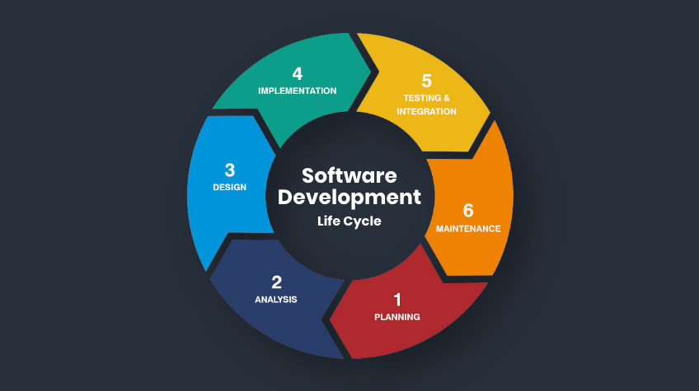**SDLC stands for Software Development Life Cycle**. **It is a systematic process for planning, Designing, Implementing (coding), testing, deploying, and maintaining software systems.** With the help of SDLC we produce high-quality software that meets customer expectations, is delivered on time and within budget, and can be easily maintained and upgraded.

1. **Planning:** Define the scope, objectives, timelines,

and resources required for the project.

1. **Design:** Create a detailed blueprint of the software,

including architecture, data structures, interfaces,

and algorithms.

1. **Implementation (Coding):** Based on the design

specifications Write the actual code for the software.

1. **Testing:** Conduct various tests to ensure the software

functions as intended and meets the specified requirements.

1. **Deployment:** Release the software for general use or to a specific set of users.
2. **Maintenance:** Regularly update and maintain the software to fix bugs, add new features, and improve performance.
3. What is DFD? Create a DFD diagram on Flipkart

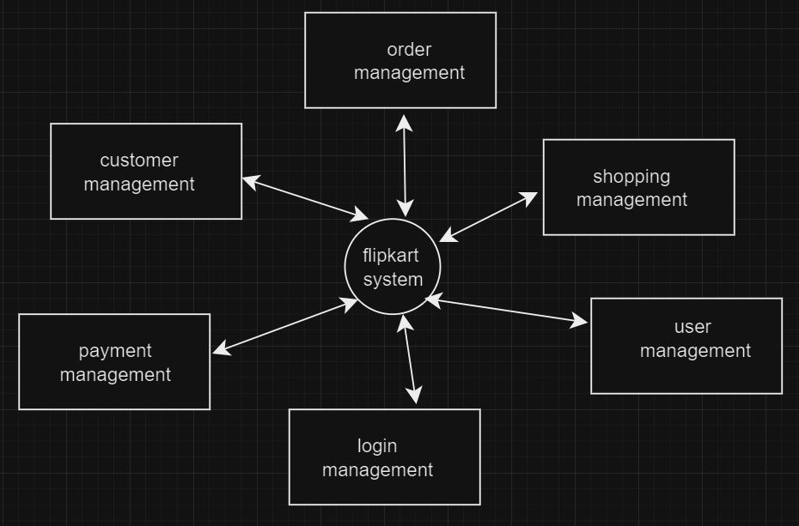DFD means Data Flow Diagram. It is a graphical representation that indicates flow of data within a system. DFDs are commonly used during the analysis and design phases of the software development life cycle with the help of DFD we can understand how data moves throughout the system and how processes transform that data.

**ZERO LEVEL DFD**

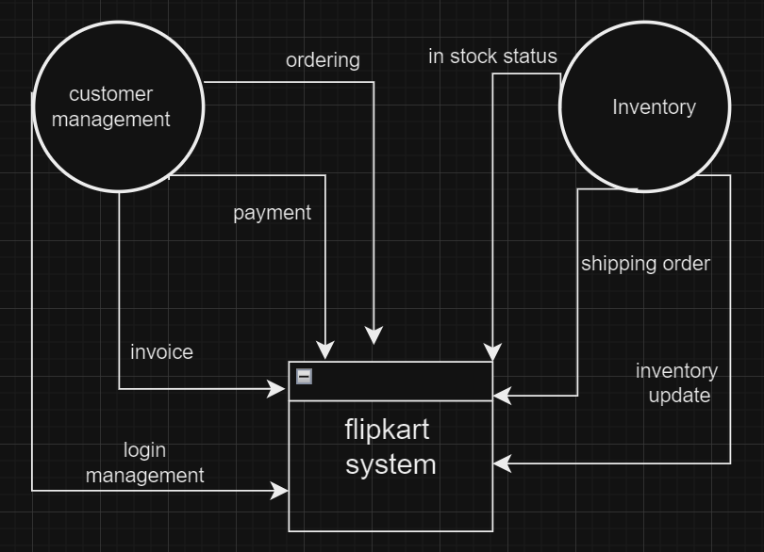**LEVEL ONE DFD**

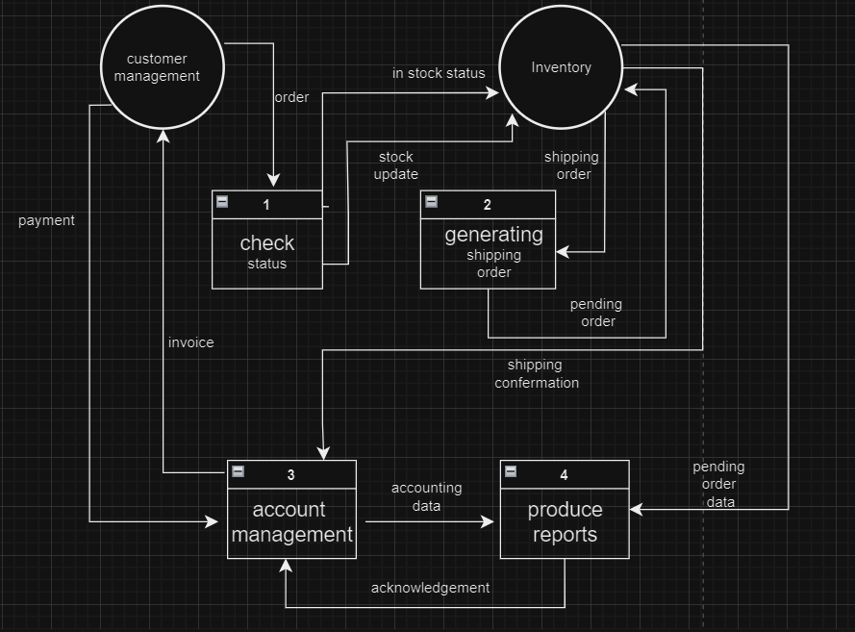

**LEVEL TWO DFD**

1. What is Flow chart? Create a flowchart to make addition of two numbers

A flowchart is a visual representation of a process or algorithm, using various shapes, symbols, and arrows to understand the steps involved. With help of flowchart we understand overview of the logical flow of a system, procedure and set of instructions.

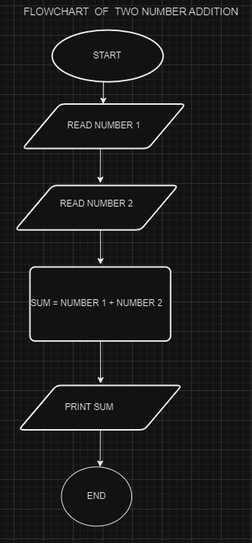

1. What is Use case Diagram? Create a use-case on bill payment on paytm.

A use case diagram is a type of Unified Modeling Language (UML) diagram that represents a system's functionalities , features and the interactions between these functionalities and external elements like users or other systems. Use case diagrams are often used in software development to capture and communicate the requirements of a system.

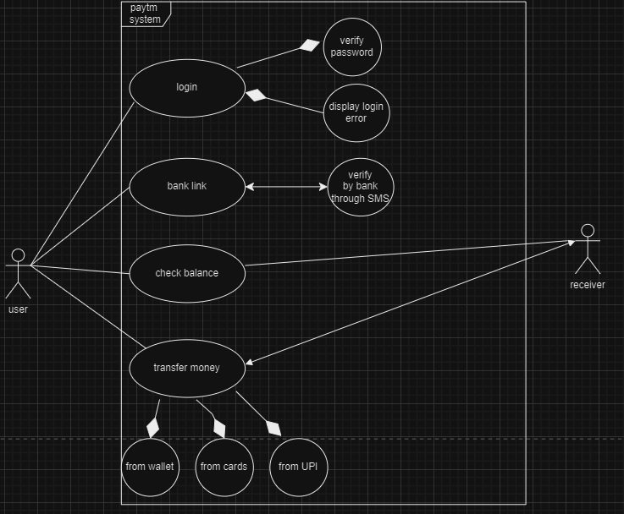

**USE CASE DIAGRAM OF PAYTM**